Instructions: Process for Faculty to set up Subcontracts for Research Proposals Where the Prime is the CON.

The research office staff can advise you on what to do and will set up the Soonertrack grant ticket for you.

- This form is used when OUHSC is the Prime applicant and we are naming a subrecipient in our grant application.
  - OUHSC should only complete the areas highlighted in yellow.
  - The subrecipient entity should complete everything else.
- The subrecipient entity (i.e., OUHSC’s partner) should provide their documents as designated by an “x” next to the name. These documents are required to consider the subrecipient proposal package to be complete. Links for the F&A Rate Agreement and Fringe Benefits Rate Agreement are acceptable. This typically includes:
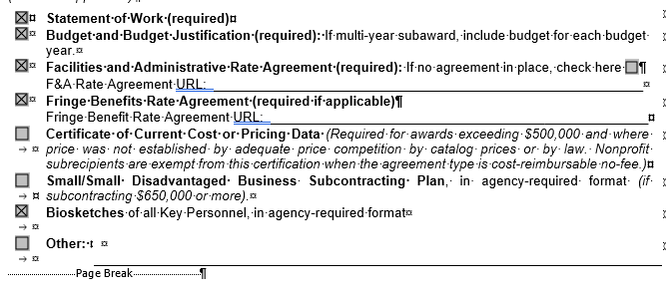
- To ensure that the research office can assist you in a timely manner, please provide us the name and contact information of
  - Faculty investigator and
  - Their contact person at the institution that you will be contracting with.

Important caveat for subcontracts. The due date to ORA is the date you want them to submit the material to the prime (the institution that will be sending in the application). They need 3 full business days. As with all funding applications, Finance will need to review the budget before the research office can upload materials to SoonerTrack.

SECTION A: Organization Information
Legal Name of Subrecipient Organization/Institution |  |  |  | Subrecipient PI
Address |  |  |  | City, State, Zip
Federal Employer Identification Number |  | DUNS or DUNS+4 Number |  |  |  | Congressional District/s
Board of Regents of the University of Oklahoma Health Sciences Center
Prime Sponsor |  |  |  | OUHSC PI

SECTION B: Subrecipient Contacts
Administrative Contact
Name:
Address:
Telephone:
Fax:
Email:
Project Director/Principal Investigator Contact
Name:
Address:
Telephone:
Fax:
Email:
Financial Contact
Name:
Address:
Telephone:
Fax:
Email:
Authorized Official Contact
Name:
Address:
Telephone:
Fax:
Email:

SECTION C: Project Information

Project Title:
Period of Performance: |  |  | to
Performance Site: Address | (if same as above, enter N/A)
Congressional District:
Direct Cost: |  | Indirect Cost |  |  | Total Project Cost

- Will Human Subjects be involved in this project? Yes No Approval Date:
If YES, copies of the IRB approval and approved "Informed Consent" form must be provided before a subaward may be issued. Please forward these documents to the OUHSC administrative contact as soon as they become available.
If YES, have all key personnel involved completed Human Subjects Training? Yes No
- Does Subrecipient have a Federal-wide Assurance (FWA) Number? Yes No
If YES, please provide FWA Number:
- Is Subrecipient’s IRB AAHRPP accredited? Yes No
- Will Animal Subjects be involved in this project? Yes No Approval Date:
If YES, a copy of the IACUC approval must be provided before a subaward may be issued. Please forward this document to the OUHSC administrative contact as soon as it becomes available.
- Does Subrecipient have a PHS Animal Welfare Assurance (AWA) Number? Yes No
If YES, please provide PHS AWA Number:
- Is Subrecipient’s IACUC AAALAC accredited? Yes No
The following documents are attached to this Subaward Commitment Form and included in the Subrecipient’s proposal submission for OUHSC’s consideration and are covered by the certifications below: (check as applicable)
Statement of Work (required)
Budget and Budget Justification (required): If multi-year subaward, include budget for each budget year.
Facilities and Administrative Rate Agreement (required): If no agreement in place, check here
F&A Rate Agreement URL:___________________________________________________________
Fringe Benefits Rate Agreement (required if applicable)
Fringe Benefit Rate Agreement URL:____________________________________________________
Certificate of Current Cost or Pricing Data (Required for awards exceeding $500,000 and where price was not established by adequate price competition by catalog prices or by law. Nonprofit subrecipients are exempt from this certification when the agreement type is cost-reimbursable no-fee.)
Small/Small Disadvantaged Business Subcontracting Plan, in agency-required format (if subcontracting $650,000 or more).
Biosketches of all Key Personnel, in agency-required format
Other:

SECTION D: Conflict of Interest

Conflict of Interest Policy Certification

Please select one of the following that applies to the Subrecipient:
Not applicable: This project is not being funded by flow-through funds from NIH, NSF, or other sponsor that has adopted the PHS federal financial disclosure requirements.
Subrecipient certifies that it has an active and enforced Conflict of Interest policy that is consistent with the provision of 42 CFR Part 50, Subpart F “Responsibility of Applicants for Promoting Objectivity in Research.” Subrecipient also certifies that, to the best of its knowledge, (1) all financial disclosures have been made related to the activities that may be funded by or through a resulting agreement, and required by its conflict of interest policy; and (2) all identified conflicts of interest have or will have been satisfactorily managed, reduced, or eliminated in accordance with Subrecipient’s Conflict of Interest policy prior to the expenditures of any funds under any resultant agreement.
Subrecipient does not have an active and/or enforced conflict of interest policy and agrees to abide by OUHSC’s Conflict of Interest policy.

SECTION E: Comments

APPROVED FOR SUBRECIPIENT
The information, certifications, and representations above have been read, signed, and made by an authorized official of the Subrecipient named herein. The appropriate programmatic and administrative personnel involved in this application are aware of awarding agency policy in regard to subawards and are prepared to establish the necessary inter-institutional agreements consistent with those policies. Any work performed and/or expenses incurred prior to execution of a subaward agreement are at the Subrecipient’s own risk. No monies shall be paid out to the Subrecipient until the subaward agreement is fully executed.
Signature of Subrecipient’s Authorized Official |  | Date
Printed Name |  | Title of Authorized Official

